greenthom – 300536064

ENGR110 – Solar Lab

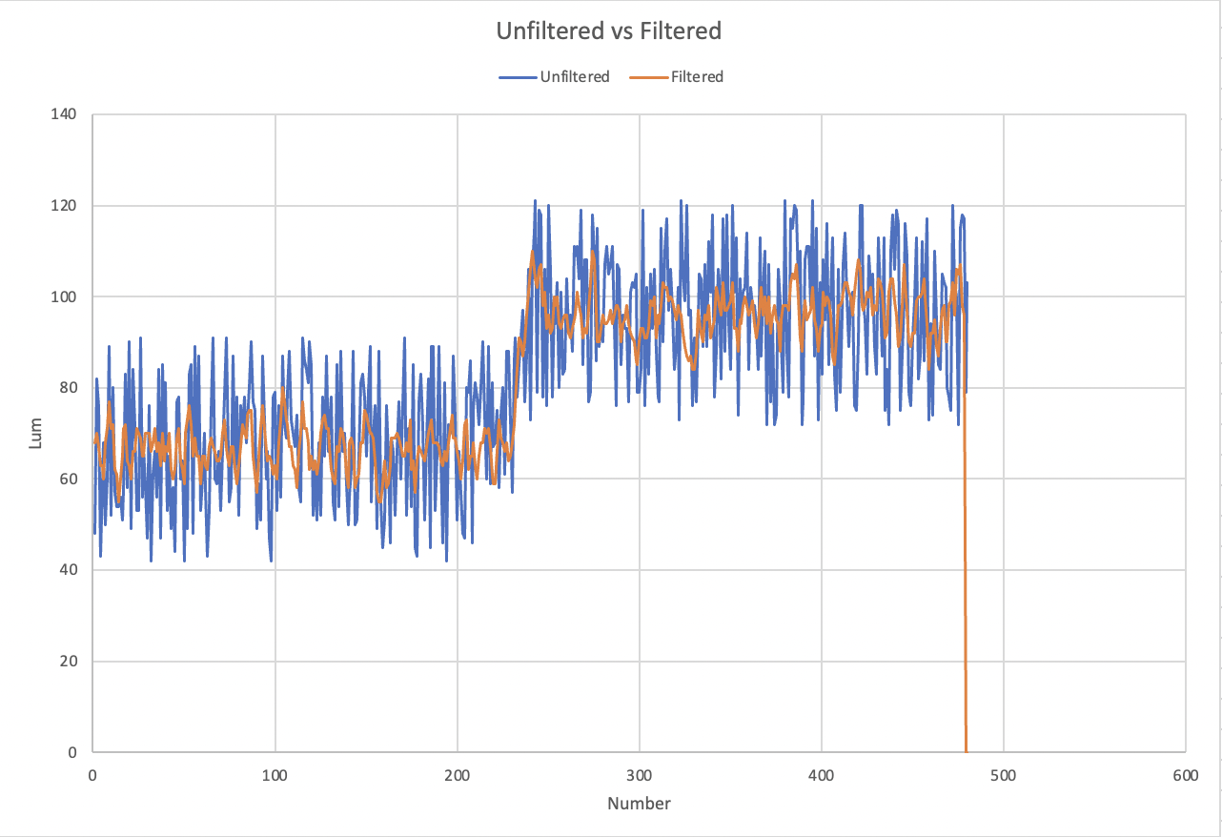Occurrence of random noise is created due to the measurement of one-pixel RGB. As this carries out, some of these pixels become darker and brighter. As the filtered image noise is less this creates a less grainy look, due to the use of the kernel passing the image through a filter (element = 1/9). Implementing the kernel creates the image less sharp causing it to blur reducing quick value variations in RGB. This method is called a low pass filter, which uses decelerated pixel to pixel variations are bottled and faster variations are decreased. The second image has less noise due to this.

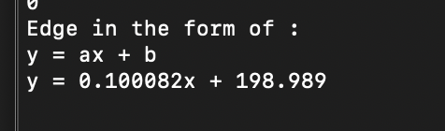Challenge: